Assignment-14

a)

CREATE TABLE STDGRADE(

S_ID INT PRIMARY KEY,

S_NAME VARCHAR(30),

GRADE int

);

INSERT INTO STDGRADE VALUES (1,'Harsha',95);

INSERT INTO STDGRADE VALUES (2,'Vishal',85);

INSERT INTO STDGRADE VALUES (3,'Abhilaash',65);

DECLARE

CURSOR grade_cursor IS

SELECT GRADE FROM STDGRADE;

student_grade STDGRADE.GRADE%TYPE;

BEGIN

FOR grade_record IN grade_cursor LOOP

student_grade := grade_record.GRADE;

IF student_grade > 90 THEN

DBMS_OUTPUT.PUT_LINE('outstanding grade');

ELSIF student_grade > 80 THEN

DBMS_OUTPUT.PUT_LINE('distinction grade');

ELSIF student_grade > 70 THEN

DBMS_OUTPUT.PUT_LINE('good grade');

ELSIF student_grade > 60 THEN

DBMS_OUTPUT.PUT_LINE('1st class grade');

ELSIF student_grade > 50 THEN

DBMS_OUTPUT.PUT_LINE('2nd class grade');

ELSE

DBMS_OUTPUT.PUT_LINE('fail grade');

END IF;

END LOOP;

END;

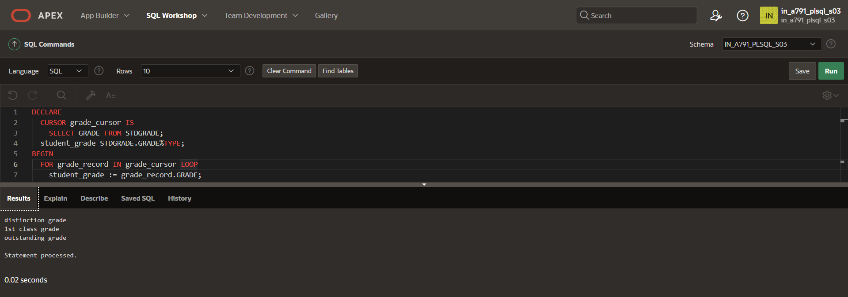

b)

declare

grade int:=81;

begin

if grade>90 then

dbms_output.put_line('outstanding grade');

elsif grade>80 then

dbms_output.put_line('distinction grade');

elsif grade>70 then

dbms_output.put_line('good grade');

elsif grade>60 then

dbms_output.put_line('1st class grade');

elsif grade>50 then

dbms_output.put_line('2nd class grade');

elsif grade<50 then

dbms_output.put_line('fail grade');

end if;

end;

